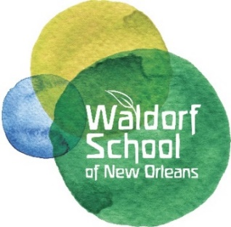

Dear Community Partner,

On Friday, February 1, 2019 we will host our 15th annual fundraiser, Starry Night at the New Orleans Jazz Market. This special evening attracts over 200 patrons and includes a silent auction, raffles, live music, dancing, and delicious food. This year’s event will feature live music by acclaimed musician, composer and Grammy Award winner Nicholas Payton. Proceeds from this year’s event will support projects including an instrument library, teachers’ assistants, facilities projects and a retirement program for faculty and staff.

We are asking for your support either as an event sponsor or a donor of a product, service, or gift certificate from your business for our silent auction. See our event sponsor opportunities on the attached page.

This is a great way for your business to be visible to a large group of parents, arts patrons, and community members. You will also be thanked through our social media, website and annual report. Because we are a non-profit 501©3 organization, all donations are tax deductible (our Federal Tax ID number is 72-1483008). A letter of your contribution will be provided for you following the event.

The Waldorf School of New Orleans is one of 1,000 schools worldwide—the only one of its kind in Louisiana—teaching a unique program that integrates academics and arts. Established in 2000, we inspire a lifelong love of learning in Nursery through Eighth Grade students. Currently with two locations uptown, our Irish Channel campus offers kindergarten through eighth grade and our Early Childhood Center offers kindergarten and nursery. In 2019 we will move into our new permanent home at the Saint Rose Collaborative in the Seventh Ward where we will be able to offer stand-alone grades classes and the full range of our programming on one campus. This is an exciting moment in the history of our school. We have tremendous potential to impact not only our own students, but to serve as a model for child-centered, arts-based education in New Orleans.

Simply fill out the donation form, then call or email us and we'll handle everything. A member of our event committee will be in touch with you soon to see if you require any additional information. Please contact us with any questions.

Thank you for your support of the Waldorf School of New Orleans!

In appreciation,
Erin Reho Pelias, Development Coordinator
development@waldorfnola.org | w. 504-525-2420 | c. 504-343-8580

Event Sponsor Opportunities

$5,000 Event Sponsor
- Only one available
- Admission for 10 at the Patron Party and Gala – reserved table
- Centrally located display of donor provided banner
- Company may provide promotional items and goodie bags
- Company featured on every table information card
- Name on web page, social media and WWNO ad
- Sponsor Gift

$2500 Bar Sponsor
- Only one available
- Admission for 6 to the Patron Party and Gala – reserved seating
- Display of donor provided banner at the bar & company name on bar napkins
- Sponsor Gift

$1000 Music Sponsors
- Admission for 4 to the Patron Party and Gala – reserved seating
- Display of donor provided banner next to band
- Sponsor Gift

$500 General Event Sponsors
- Unlimited
- Helps cover the costs of printing, decorations and food
- Name display at food stations
- Sponsor Gift

In Kind Donations of Items of Services for Silent Auction
- Unlimited
- Donors will be listed in our silent auction program
- Items will be on display through the event

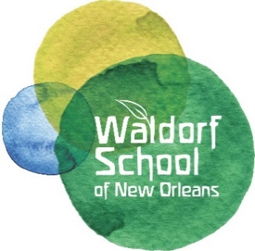
Starry Night Donation Form 2019

Donor’s Name(s): ____________________________________________

Business/Company: ____________________________________________

Mailing Address: ____________________________________________

____________________________________________

Phone Number(s): ____________________________________________

Email Address: ____________________________________________

DONATION SOLICITED BY: ______________________________________

Sponsorship Level: ___ $5,000 Event Sponsor ___ $2,500 Bar Sponsor

___ $1,000 Music Sponsor ___ $500 General Event Sponsor

In Kind Donation for Silent Auction:

Donated Item: ________________________________________________

Description: _________________________________________________

Retail Value of Item: ____________________________________________

Donated Item: ___________________________________________________

Description of Item: ______________________________________________

Retail Value of Item: ______________________________________________

